

**FINAL TERM ASSIGNMENT**

**COURSE: SOFTWARE QUALITYAND TESTING**

**SECTION: A**

Submitted By,

|  |  |
| --- | --- |
| Name | ID |
| Anik Sen | **20-42138-1** |
| Md. Fahim Alam | **20-42517-1** |

**Date of Submission: 28th March, 2023**

**Part-I: Installation Process of Selenium Webdriver for Web Application Automation Testing.**

Installation process and Setup

**Part-II: Test a Web Application Module Using Selenium Webdriver**

Select a Web Application Module Which Will be Tested

Prepare a Test Case

Write Required Code

Run and Observe the Outcomes

**Part-I**

Install Java: First, you need to have Java installed on your computer. We download the latest version of Java from the official website at https://www.oracle.com/java/technologies/downloads/.

Install an Integrated Development Environment (IDE): An IDE is a software application that provides a comprehensive environment to write, debug and run code. We use popular IDEs like NetBeans for writing Selenium code.

Set up the Selenium WebDriver: The Selenium WebDriver is a tool that allows you to interact with web browsers through code. We download the latest version of the WebDriver from the official website at https://www.selenium.dev/downloads/.

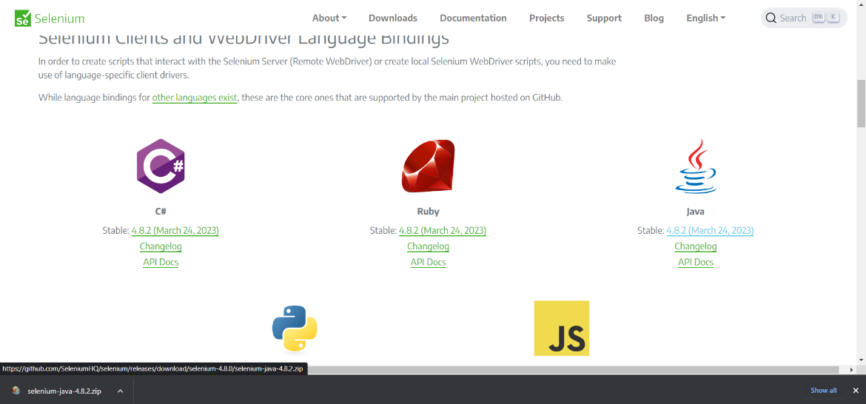

Download Chromedriver: Chromedriver is a tool that allows Selenium to interact with the Chrome browser. We download it from the official website at <https://chromedriver.chromium.org/downloads>

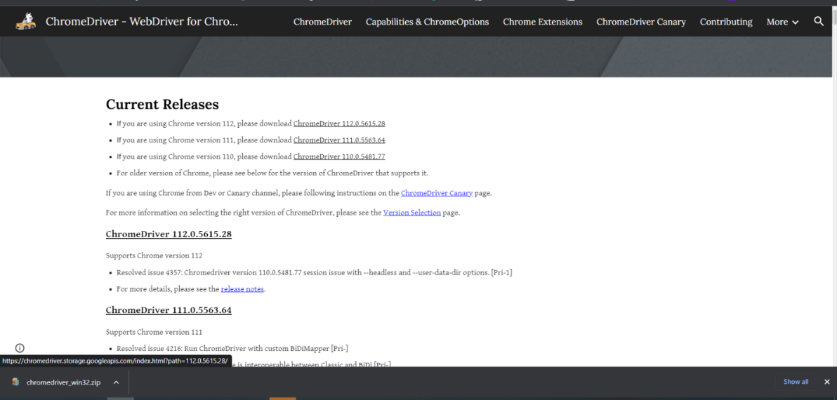

Create a new project: We Open IDE and create a new Java project. Give it the name of Our Project is automatictestingselenium

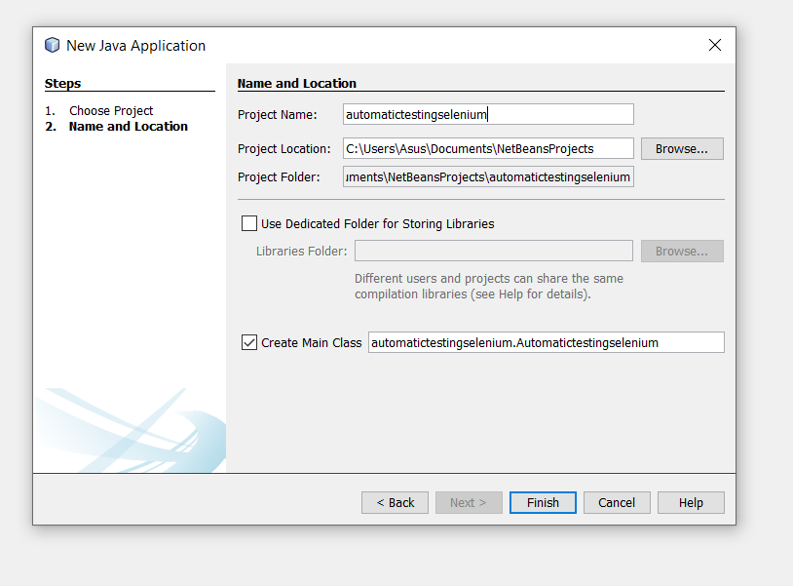

Add Selenium libraries: Add the Selenium libraries to Our project by downloading the latest version from the official website and importing them into Our project.

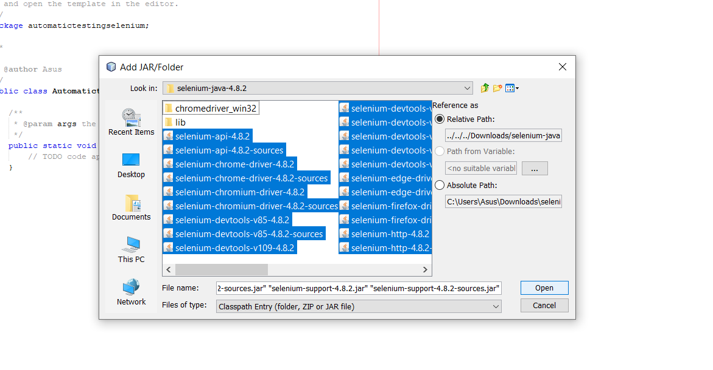

Add Chromedriver to your project: Add the Chromedriver executable to Our project's classpath. We do this by right-clicking on the project in Our IDE, selecting Build Path > Configure Build Path, and then adding the Chromedriver executable to the project's classpath.s

Run the test: Run the test by right-clicking on the Java file and selecting Run As > Java Application. This should open the Chrome browser and navigate to the Google homepage.

**Part-II**

|  |  |  |  |  |
| --- | --- | --- | --- | --- |
| Project Name: Tour guide BD | | | Test Designed by: | |
| Test Case ID: #1 | | | Test Designed date: 24th March, 2023 | |
| Test Priority: High | | | Test Executed by: Anik Sen | |
| Module Name: Sign Up | | | Test Execution date: 27th March, 2023 | |
| Test Title: Sign up with valid user name, email, phone number, NID, password. | | |  | |
| Description: Test the website sign up page | | |  | |
| Preconditions: User has valid user name, email, phone number, NID, password.  Dependencies: N/A | | | | |
| Test Steps | **Test Data** | **Expected Results** | **Actual Results** | **Status** |
| 1. Go for sign up 2. Enter user name 3. Enter email 4. Enter phone number 5. Enter NID 6. Enter password 7. Click submit | Username : Tom Latham  Email : [tomlatham@gmail.com](mailto:tomlatham@gmail.com)  NID : 5132411122332  Phone no. :01987654321  Password : tomLatham@1 | User should sign up successfully. | As expected | Pass |
| Post Condition: user is validated with the database and successfully sign up to account. | | | | |

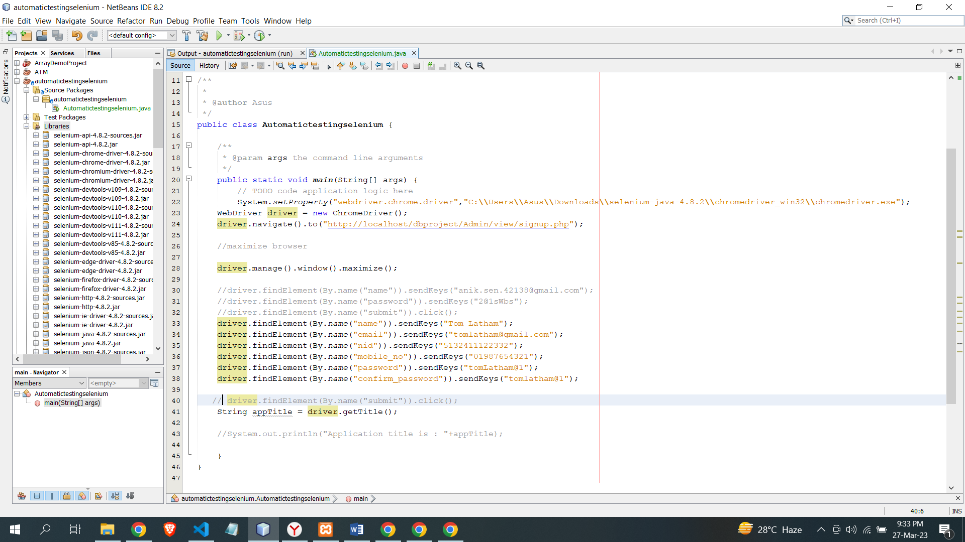

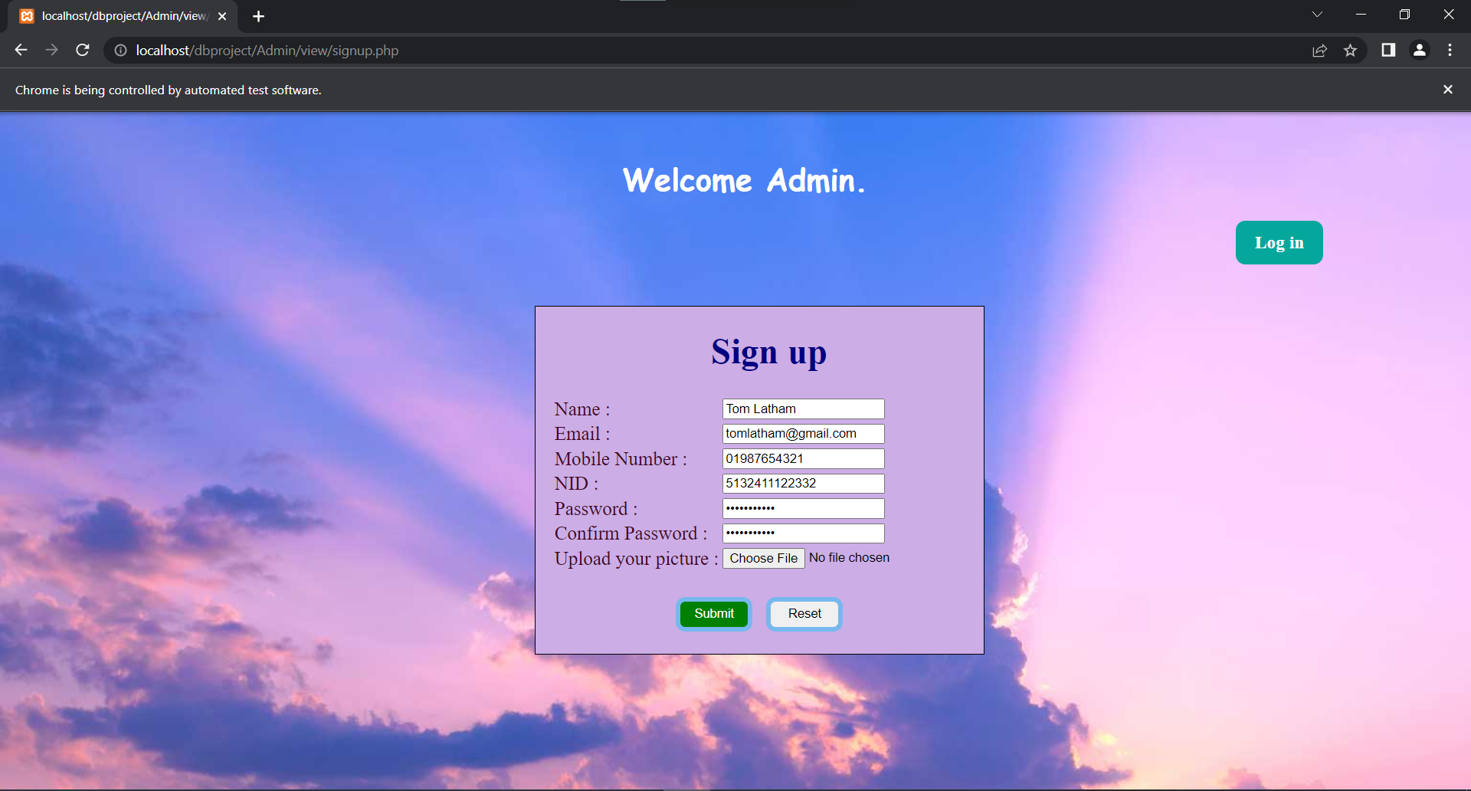

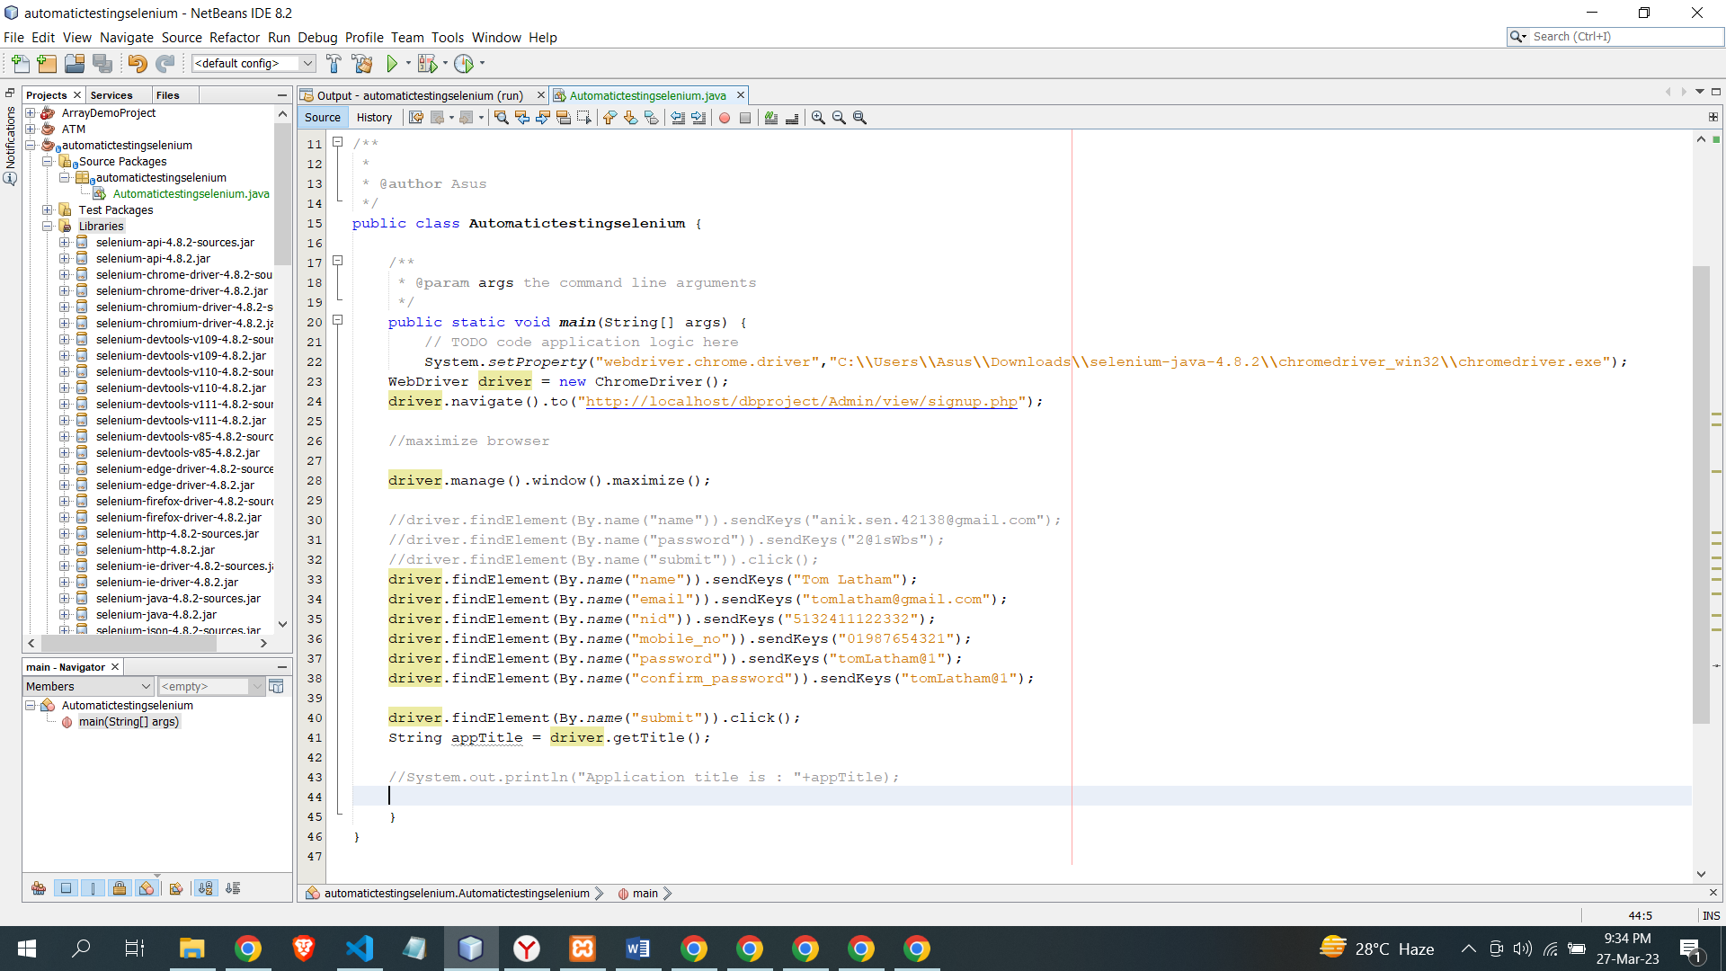

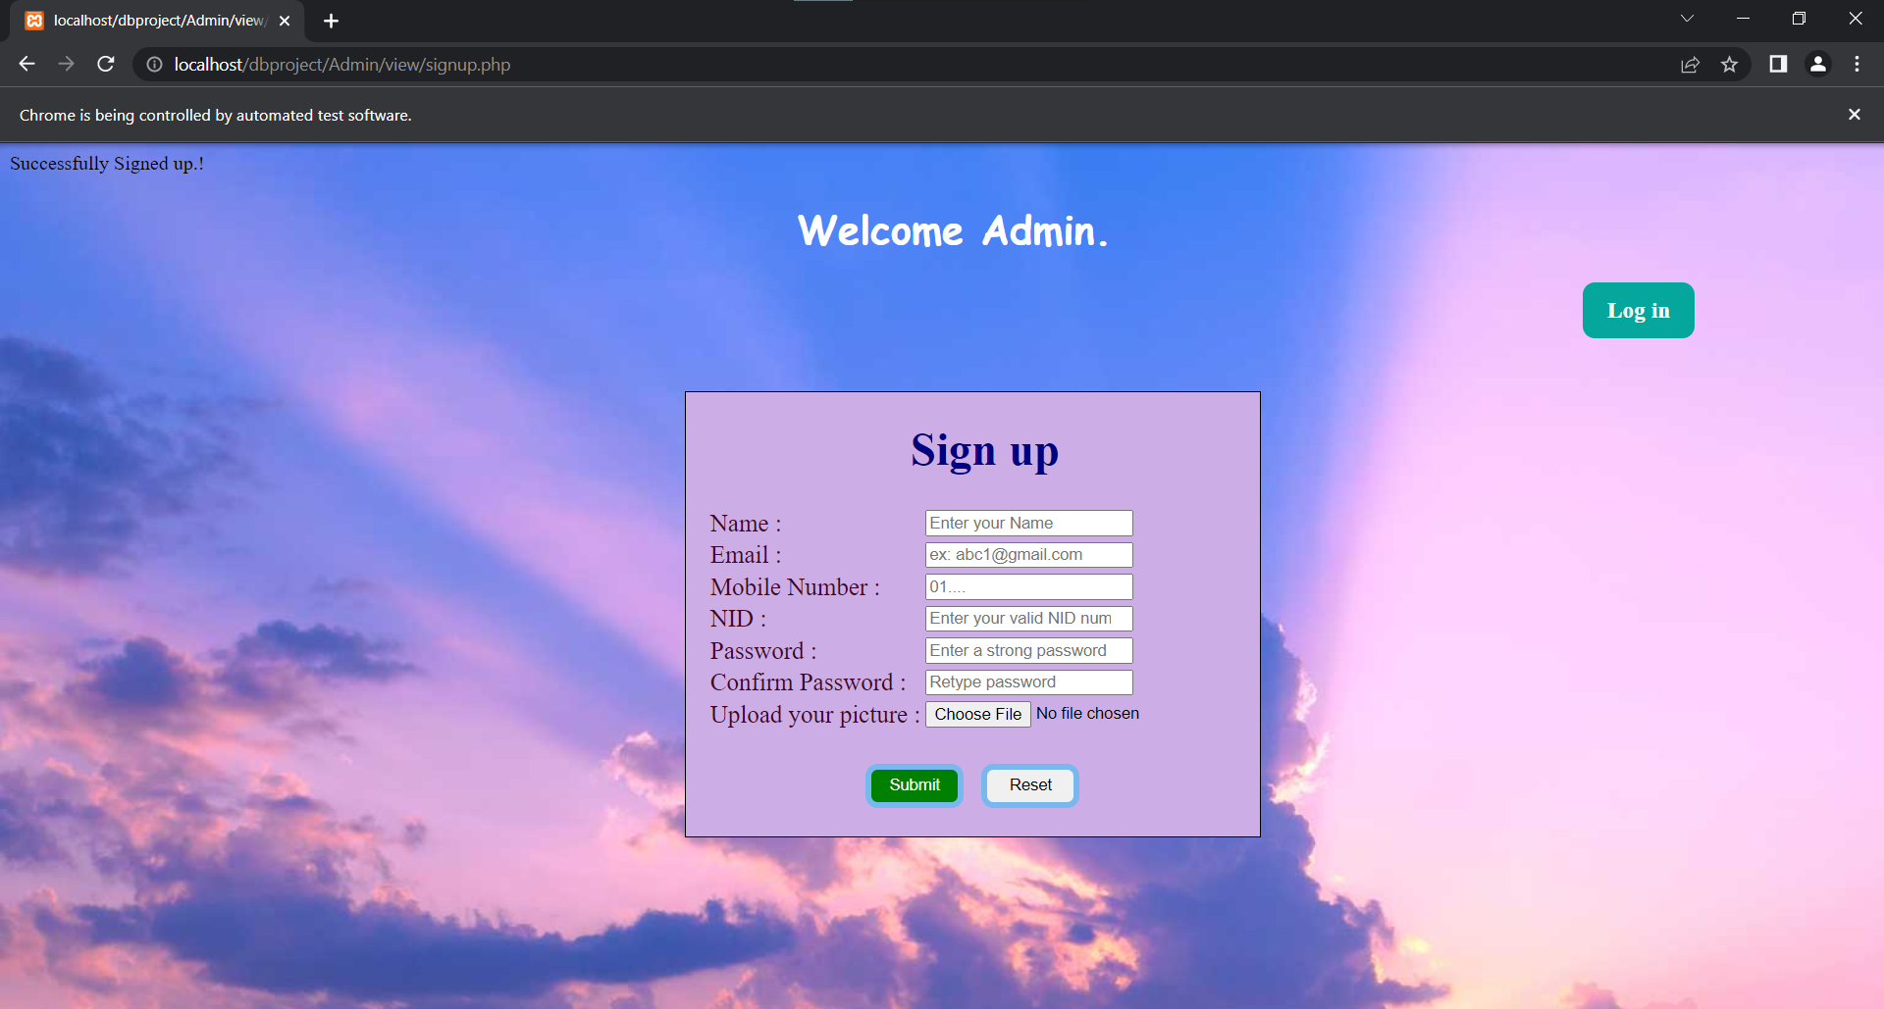

|  |  |  |  |  |
| --- | --- | --- | --- | --- |
| Project Name: Tour guide BD | | | Test Designed by: | |
| Test Case ID: #2 | | | Test Designed date: 24th March, 2023 | |
| Test Priority: High | | | Test Executed by: Anik Sen | |
| Module Name: Log In | | | Test Execution date: 27th March, 2023 | |
| Test Title: Verify log in with valid user name and password | | |  | |
| Description: Test the website login page | | |  | |
| Preconditions: User has valid user name and password  Dependencies: N/A | | | | |
| Test Steps | **Test Data** | **Expected Results** | **Actual Results** | **Status** |
| 1. Go for log in 2. Enter user name 3. Enter password 4. Click log in | Username : anik.sen.42138@gmail.com  Password : 2@1sWbs | User should log in into the application | As expected | Pass |
| Post Condition: user is validated with the database and successfully log in to account. The account session details are logged in the database. | | | | |

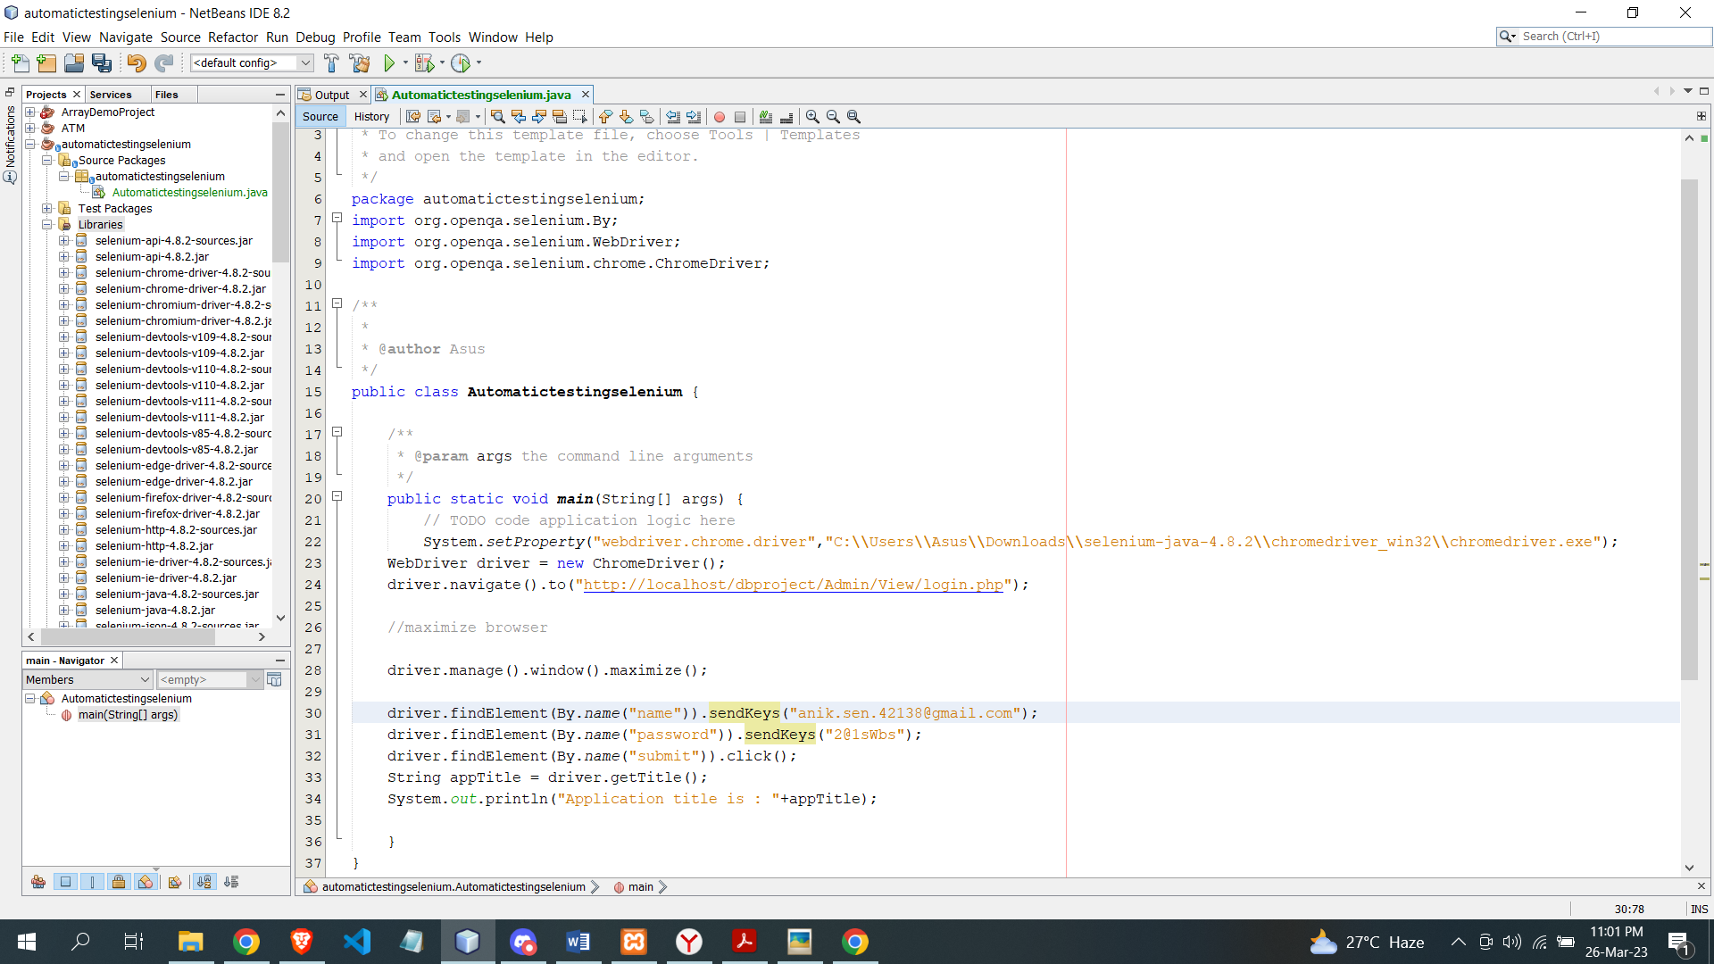

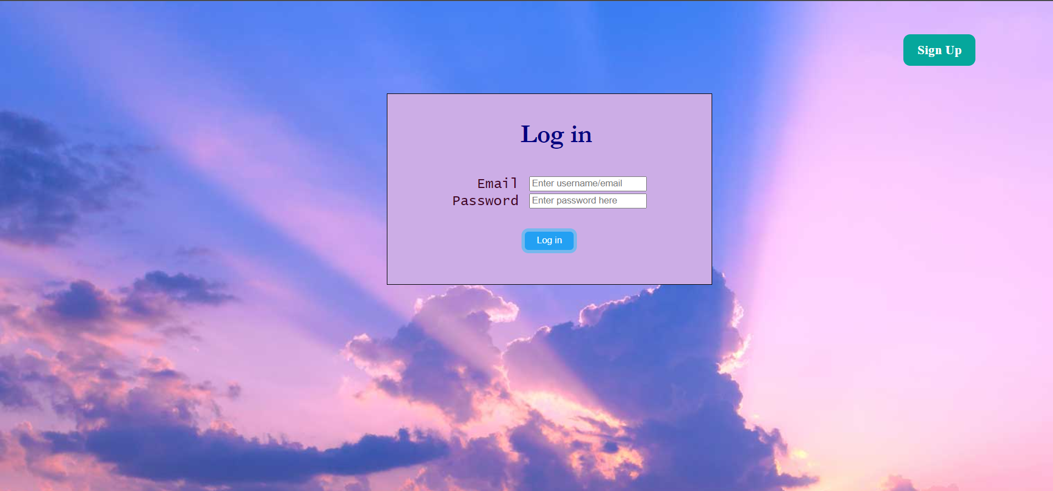

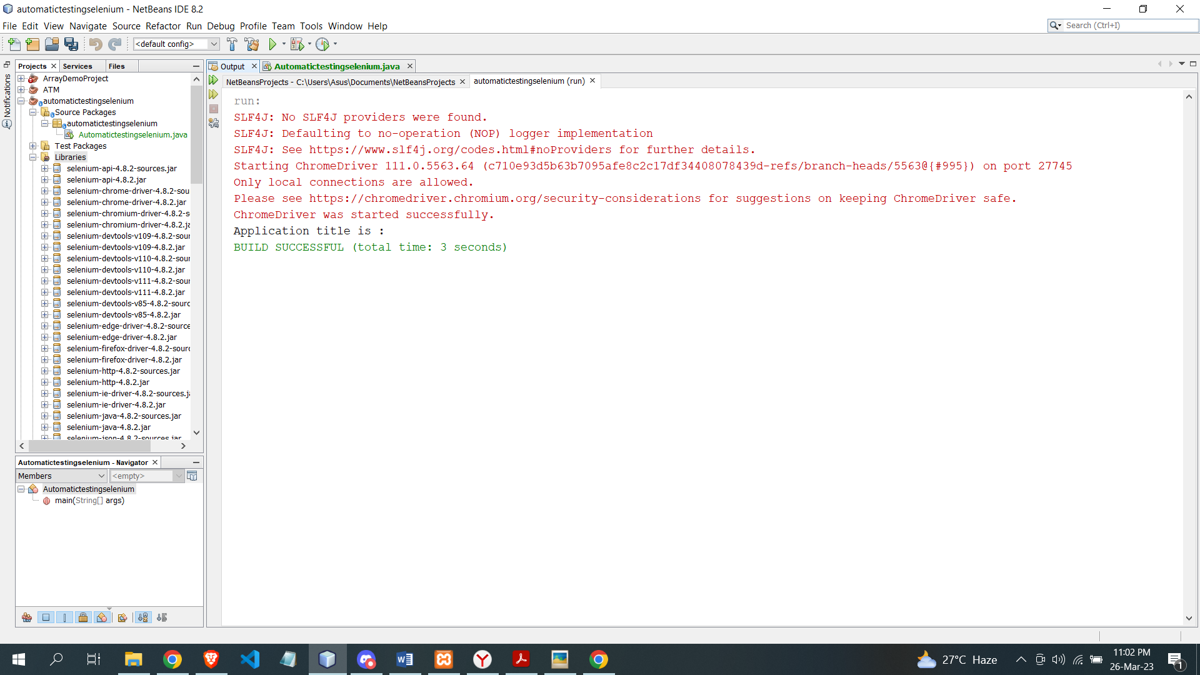

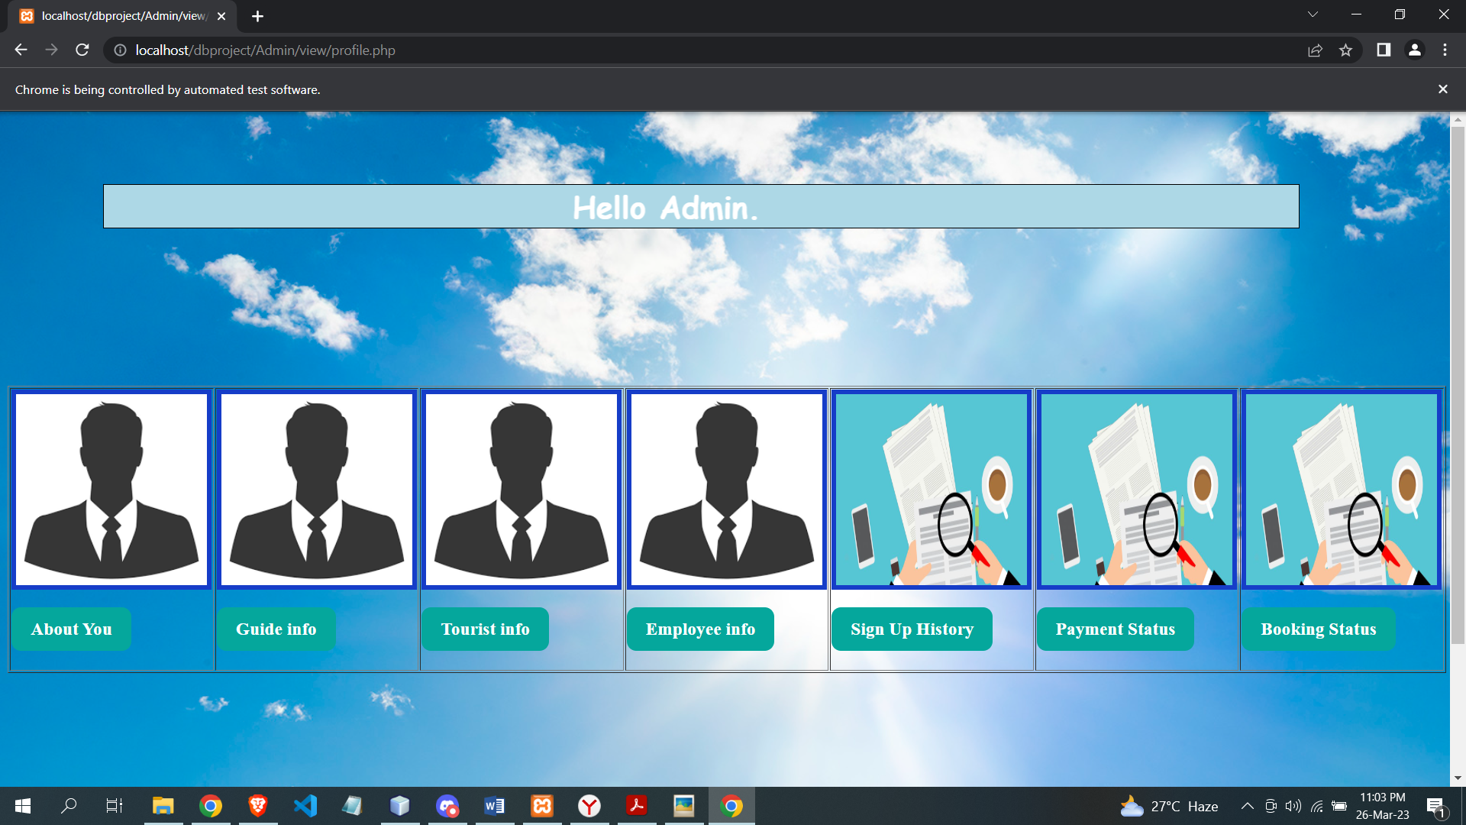

|  |  |  |  |  |
| --- | --- | --- | --- | --- |
| Project Name: Tour guide BD | | | Test Designed by: | |
| Test Case ID: #3 | | | Test Designed date: 24th March, 2023 | |
| Test Priority: High | | | Test Executed by: Anik Sen | |
| Module Name: Update Info | | | Test Execution date: 27th March, 2023 | |
| Test Title: Update user info | | |  | |
| Description: Test the website update admin info page | | |  | |
| Preconditions: User has valid data  Dependencies: N/A | | | | |
| Test Steps | **Test Data** | **Expected Results** | **Actual Results** | **Status** |
| 1. Go for update 2. Enter update name 3. Enter update email 4. Enter update NID 5. Enter update phone 6. Click submit | Name : Hira  Email : hiraa@gmail.com  NID : 6899630260  Phone : 1234567891 | User should update his information | As expected | Pass |
| Post Condition: user is validated with the database and successfully update. | | | | |

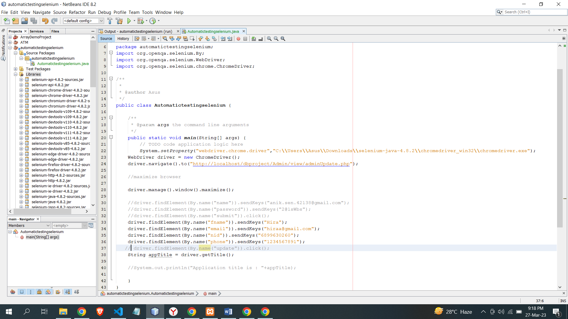

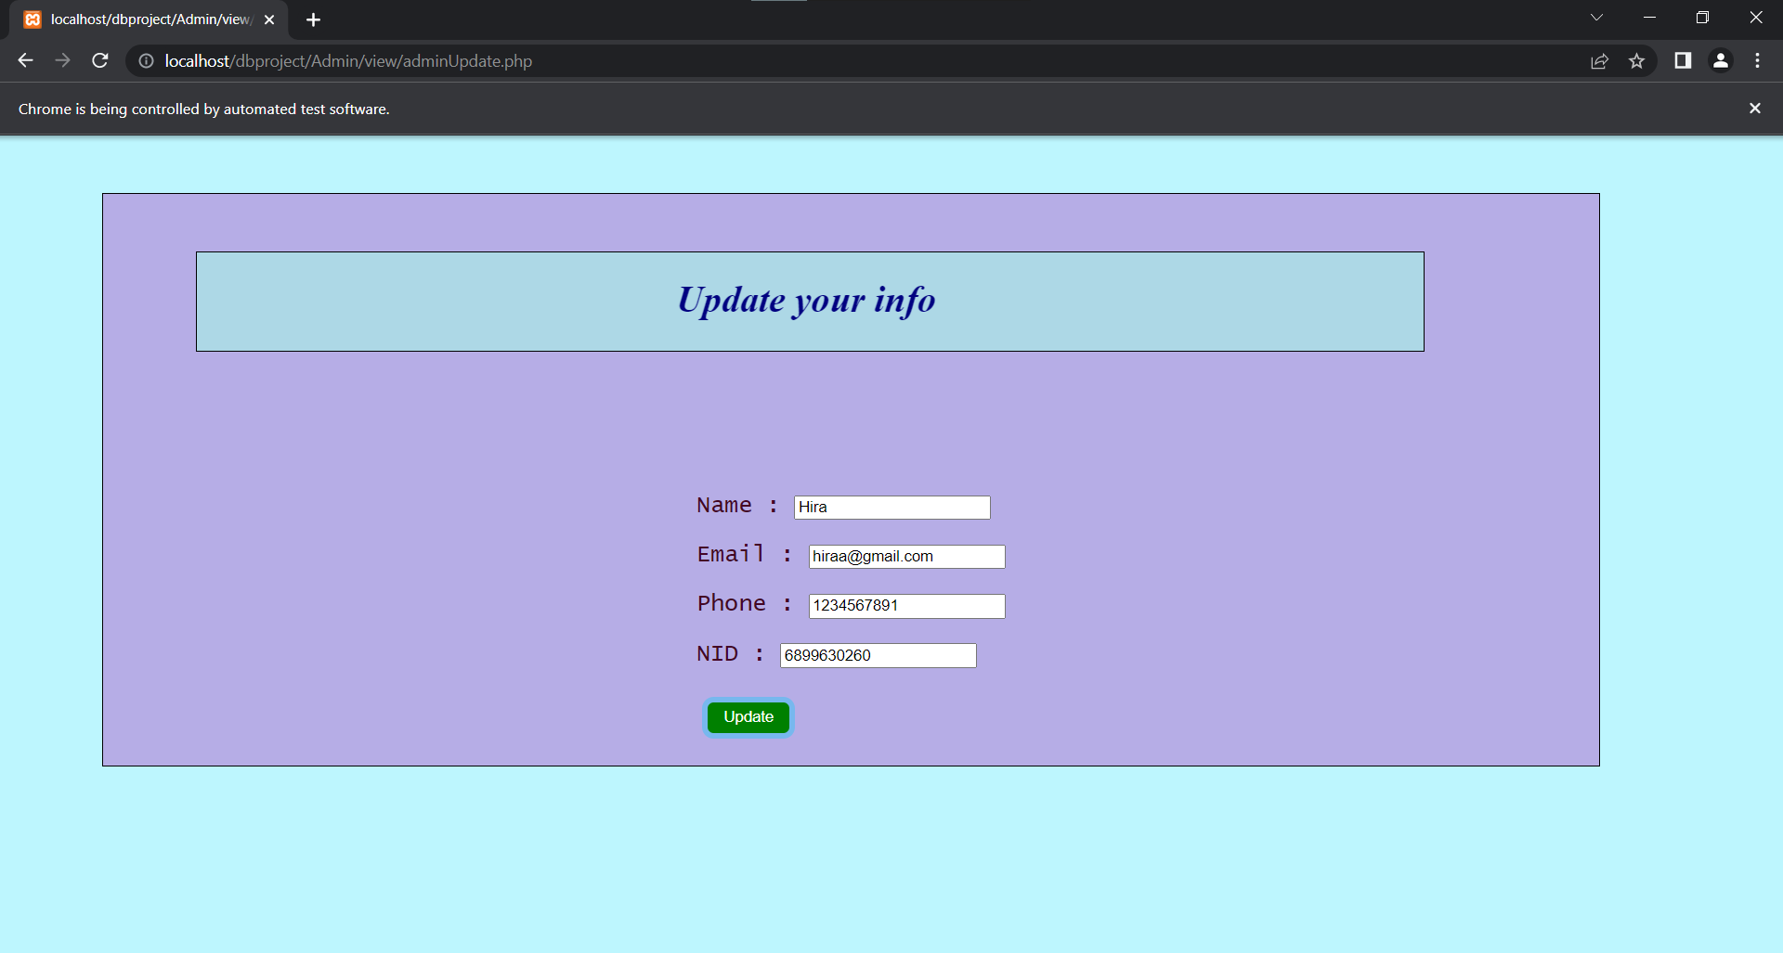

|  |  |  |  |  |  |  |
| --- | --- | --- | --- | --- | --- | --- |
| Project Name: Tour guide BD | | | |  | Test Designed by: | |
| Test Case ID: #4 | | | |  | Test Designed date: 24th March, 2023 | |
| Test Priority: Medium | | | |  | Test Executed by: Anik Sen | |
| Module Name: Admins data | | | |  | Test Execution date: 27th March, 2023 | |
| Test Title: See the admins data | | | |  |  | |
| Description: Test the existing of all admins data | | | |  |  | |
|  | | Preconditions: Database should consist all admins info  Dependencies: N/A | | | | |
| Test Steps | **Test Data** | | **Expected Results** |  | **Actual Results** | **Status** |
| 1. Go for check general info 2. Click to check | N/A | | Fetch all data and make it visible |  | As expected | Pass |
|  | | Post Condition: N/A | | | | |

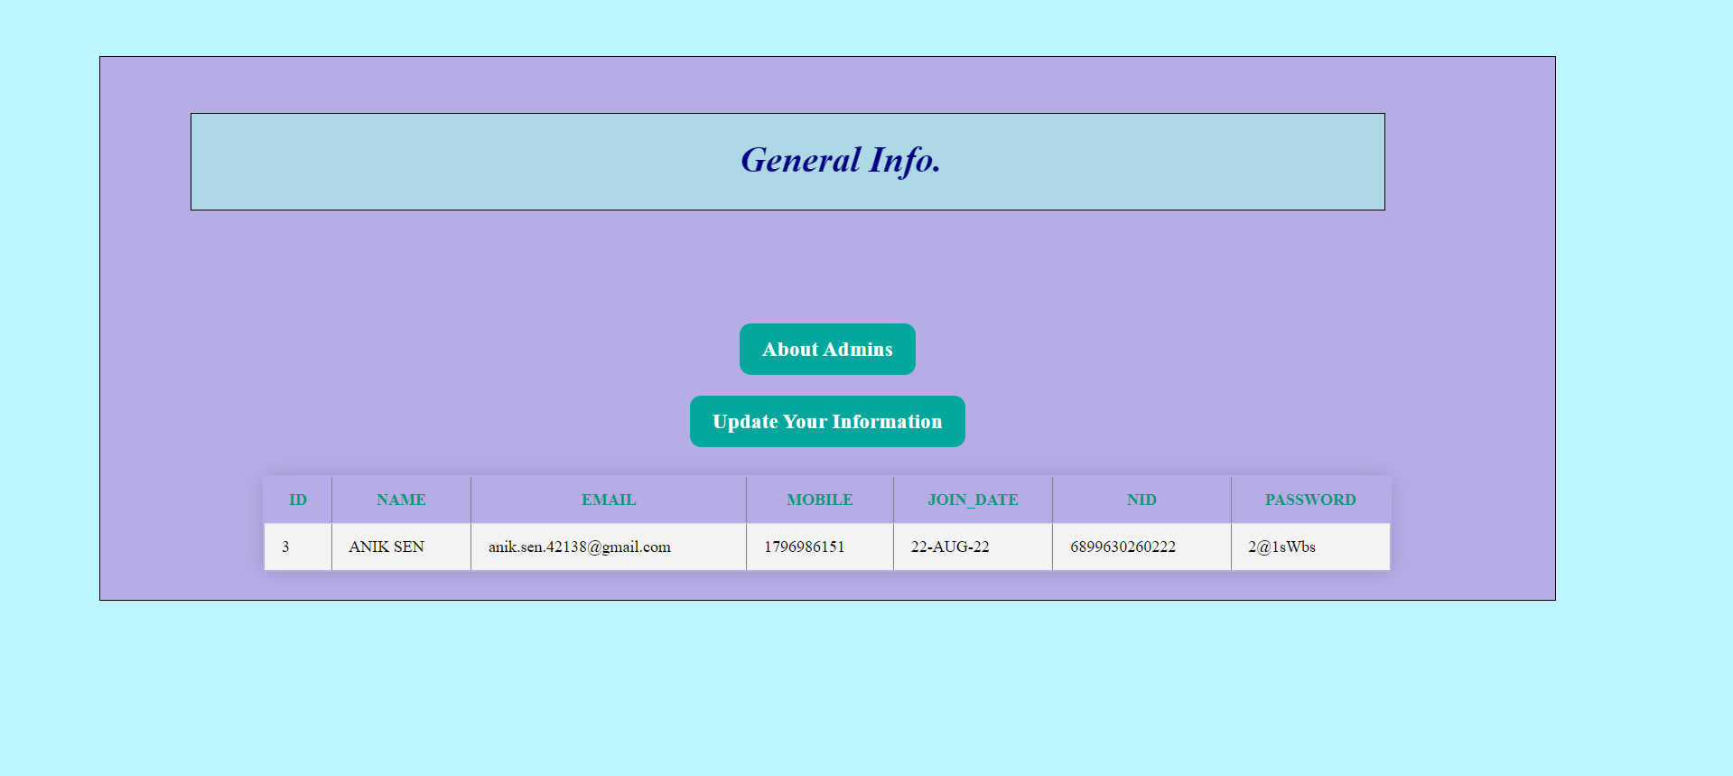

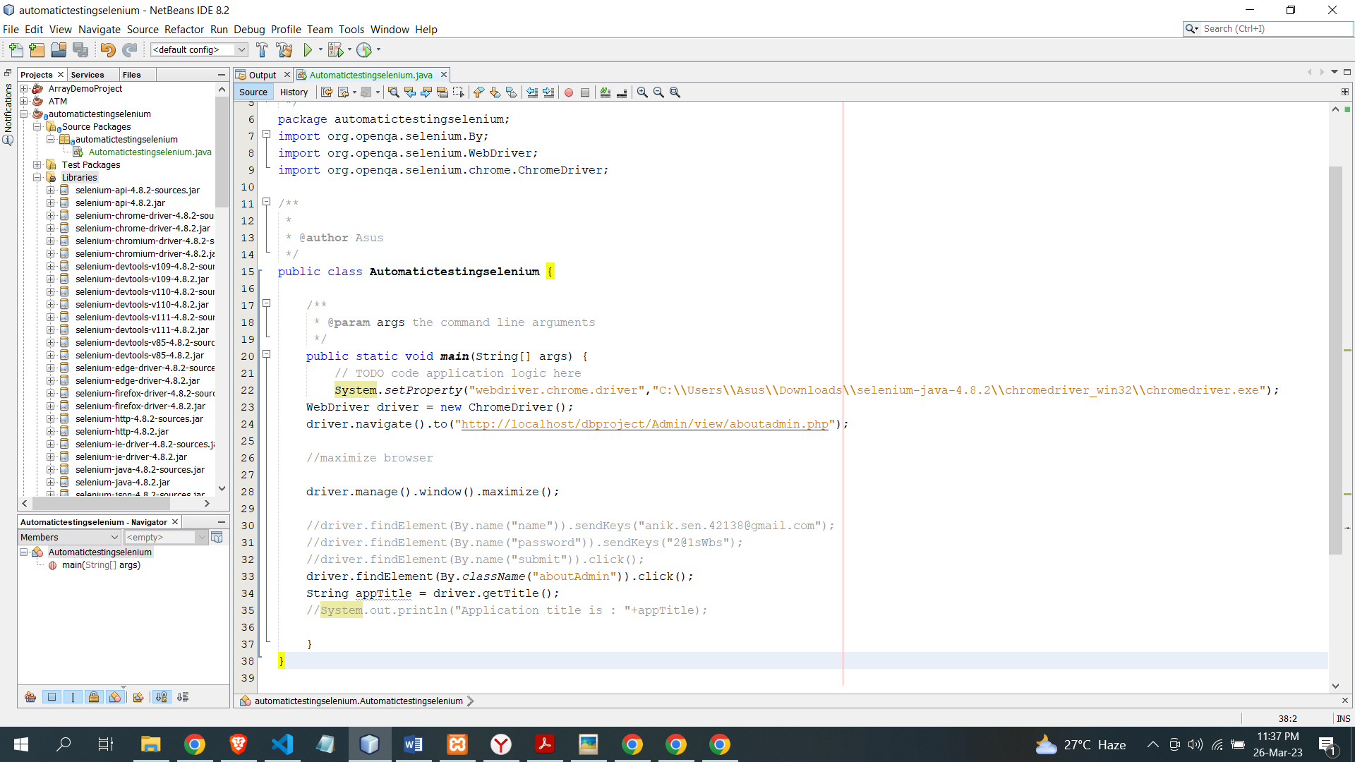

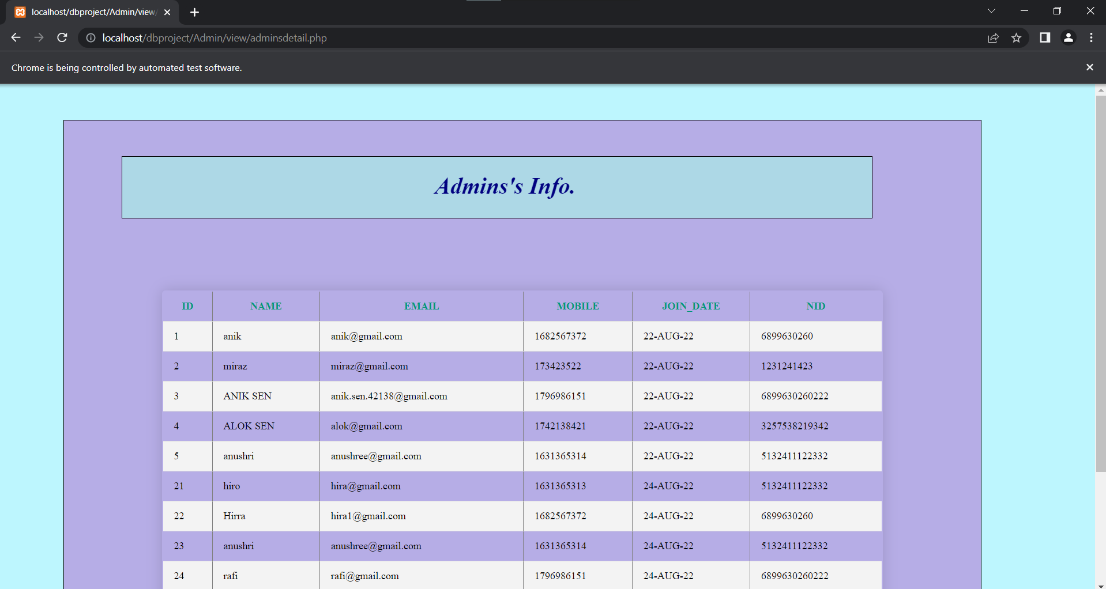

|  |  |  |  |  |
| --- | --- | --- | --- | --- |
| Project Name: Tour guide BD | | | Test Designed by: | |
| Test Case ID: #5 | | | Test Designed date: 24th March, 2023 | |
| Test Priority: Medium | | | Test Executed by: Anik Sen | |
| Module Name: Tourist data | | | Test Execution date: 27th March, 2023 | |
| Test Title: See the tourist data | | |  | |
| Description: Test the existing of all tourist data | | |  | |
| Preconditions: Database should consist all tourist info  Dependencies: N/A | | | | |
| Test Steps | **Test Data** | **Expected Results** | **Actual Results** | **Status** |
| 1. Go for check general info 2. Click to check | N/A | Fetch all data and make it visible | As expected | Pass |
| Post Condition: N/A | | | | |

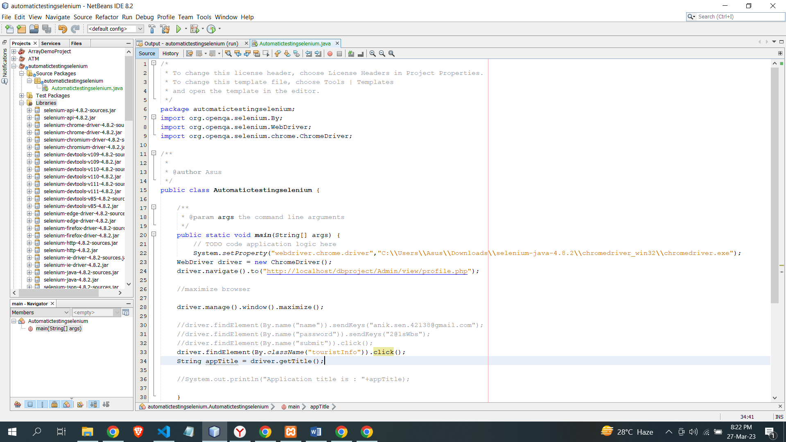

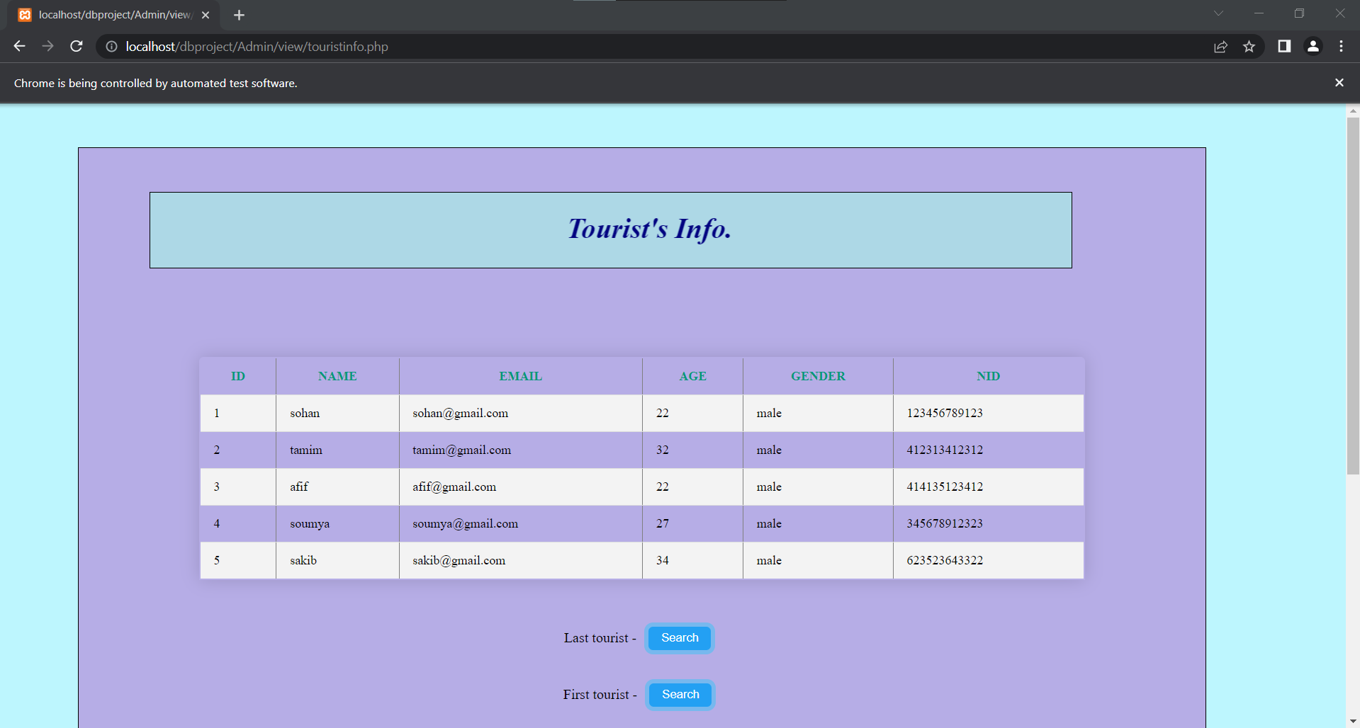

|  |  |  |  |  |
| --- | --- | --- | --- | --- |
| Project Name: Tour guide BD | | | Test Designed by: | |
| Test Case ID: #6 | | | Test Designed date: 24th March, 2023 | |
| Test Priority: Medium | | | Test Executed by: Fahim Alam | |
| Module Name: Check info | | | Test Execution date: 27th March, 2023 | |
| Test Title: See the Bkash user info | | |  | |
| Description: Test the Bkash user info | | |  | |
| Preconditions: Database should consist all Bkash user info  Dependencies: N/A | | | | |
| Test Steps | **Test Data** | **Expected Results** | **Actual Results** | **Status** |
| 1. Go for check general info 2. Click search option on Bkash user | N/A | Fetch all data and make it visible | As expected | Pass |
| Post Condition: N/A | | | | |

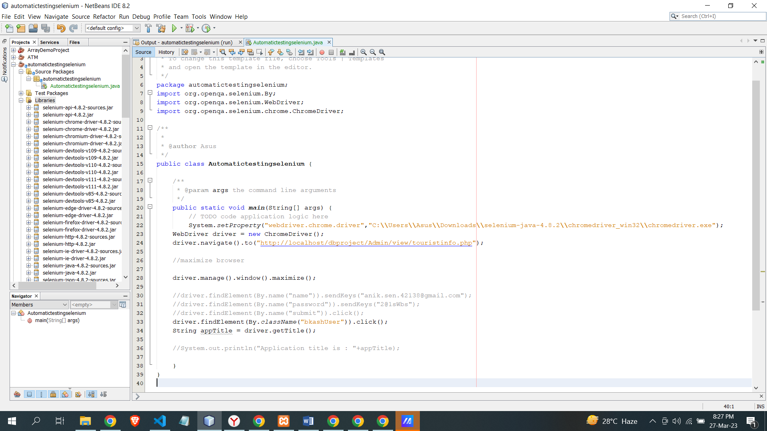

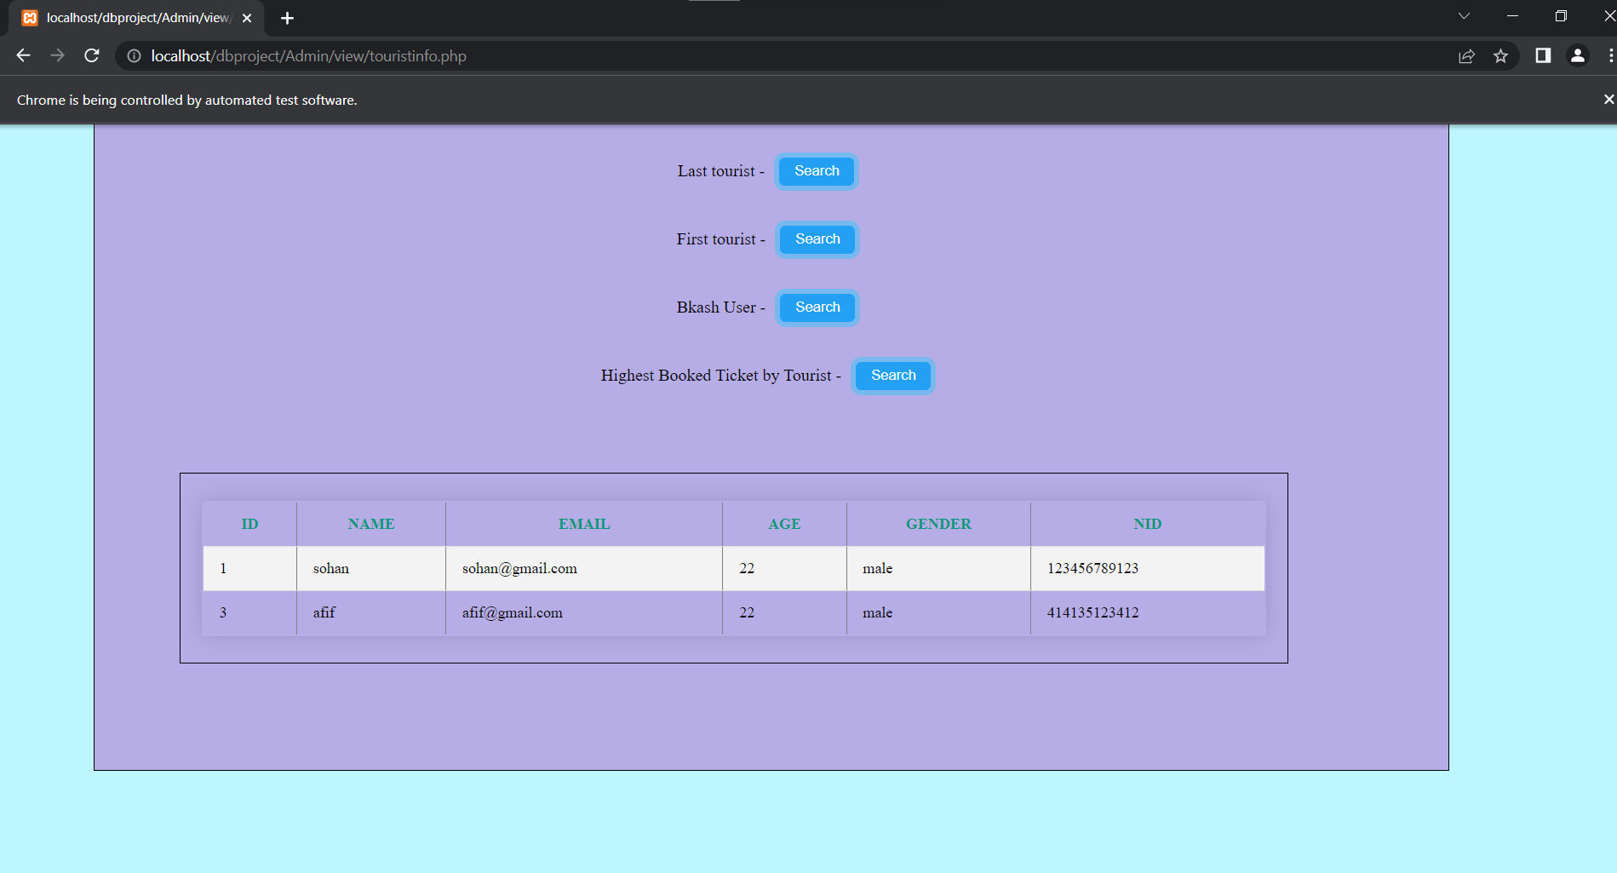

|  |  |  |  |  |
| --- | --- | --- | --- | --- |
| Project Name: Tour guide BD | | | Test Designed by: | |
| Test Case ID: #7 | | | Test Designed date: 24th March, 2023 | |
| Test Priority: Medium | | | Test Executed by: Fahim Alam | |
| Module Name: Check info | | | Test Execution date: 27th March, 2023 | |
| Test Title: Search specific user info | | |  | |
| Description: Test searching of specific user info | | |  | |
| Preconditions: Database should consist all user info  Dependencies: N/A | | | | |
| Test Steps | **Test Data** | **Expected Results** | **Actual Results** | **Status** |
| 1. Go for check general info 2. Type user id 3. Click on search option | ID : 5 | Fetch the data and make it visible | As expected | Pass |
| Post Condition: N/A | | | | |

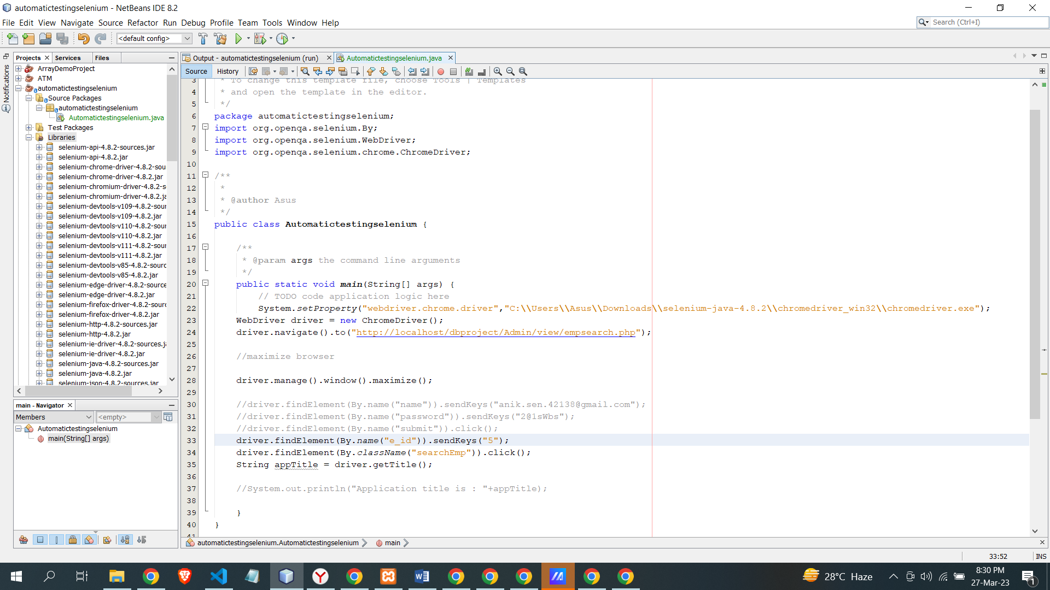

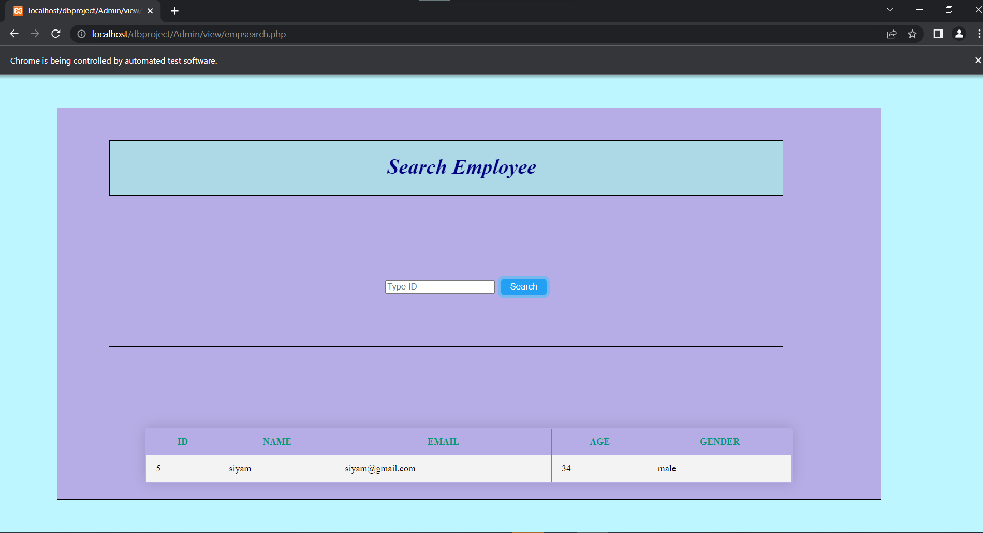

|  |  |  |  |  |
| --- | --- | --- | --- | --- |
| Project Name: Tour guide BD | | | Test Designed by: | |
| Test Case ID: #8 | | | Test Designed date: 24th March, 2023 | |
| Test Priority: High | | | Test Executed by: Fahim Alam | |
| Module Name: Update Salary | | | Test Execution date: 27th March, 2023 | |
| Test Title: Update of employee salary | | |  | |
| Description: Test the update segment of employee salary | | |  | |
| Preconditions: N/A  Dependencies: N/A | | | | |
| Test Steps | **Test Data** | **Expected Results** | **Actual Results** | **Status** |
| 1. Go for update 2. Enter employee grade 3. Enter updated salary 4. Click submit | Grade : 1  Salary : 5500 | Admin should update employee salary | As expected | Pass |
| Post Condition: N/A | | | | |

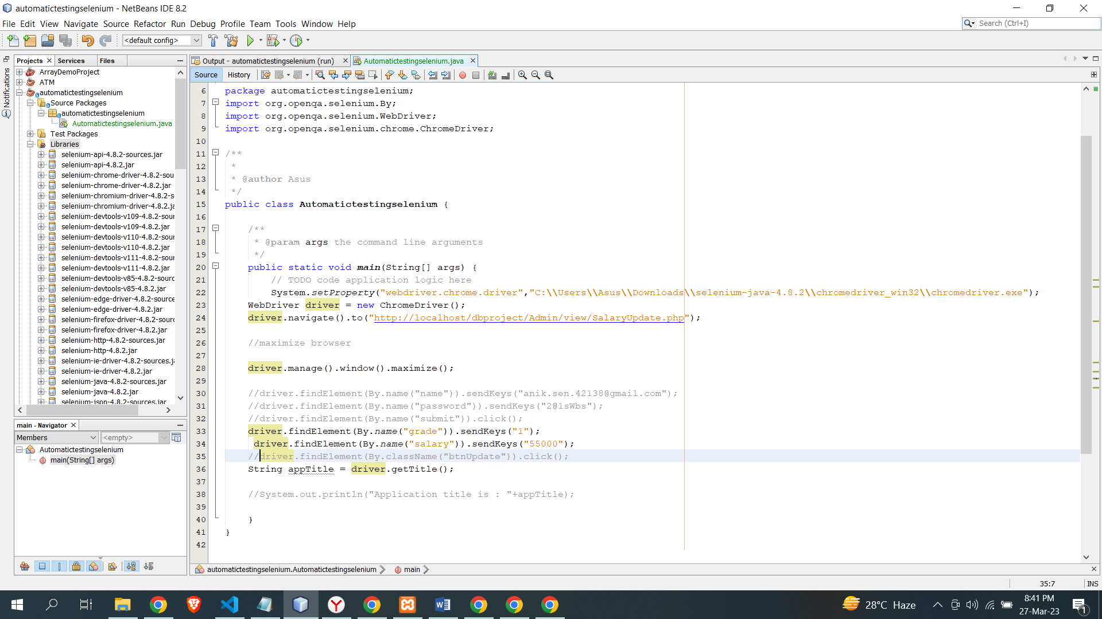

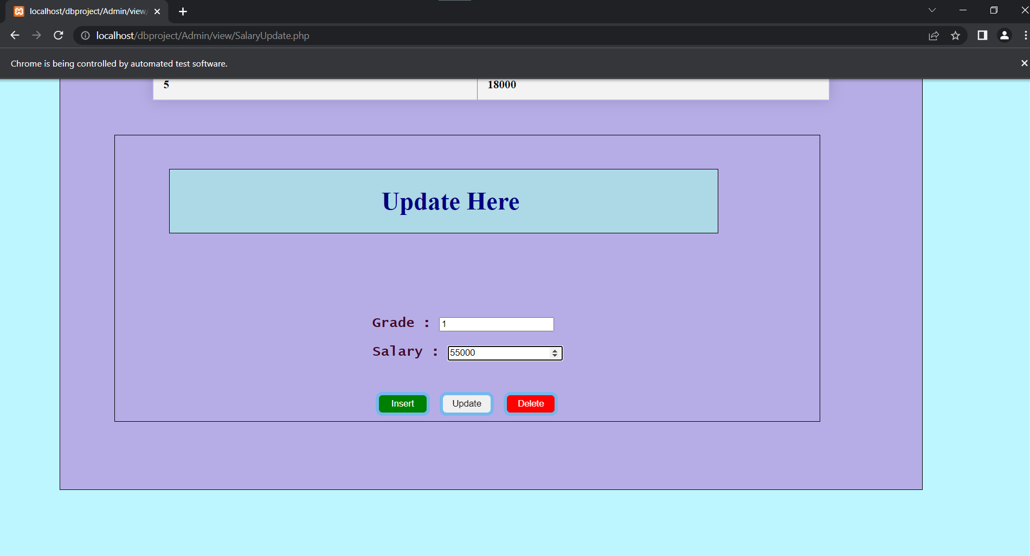

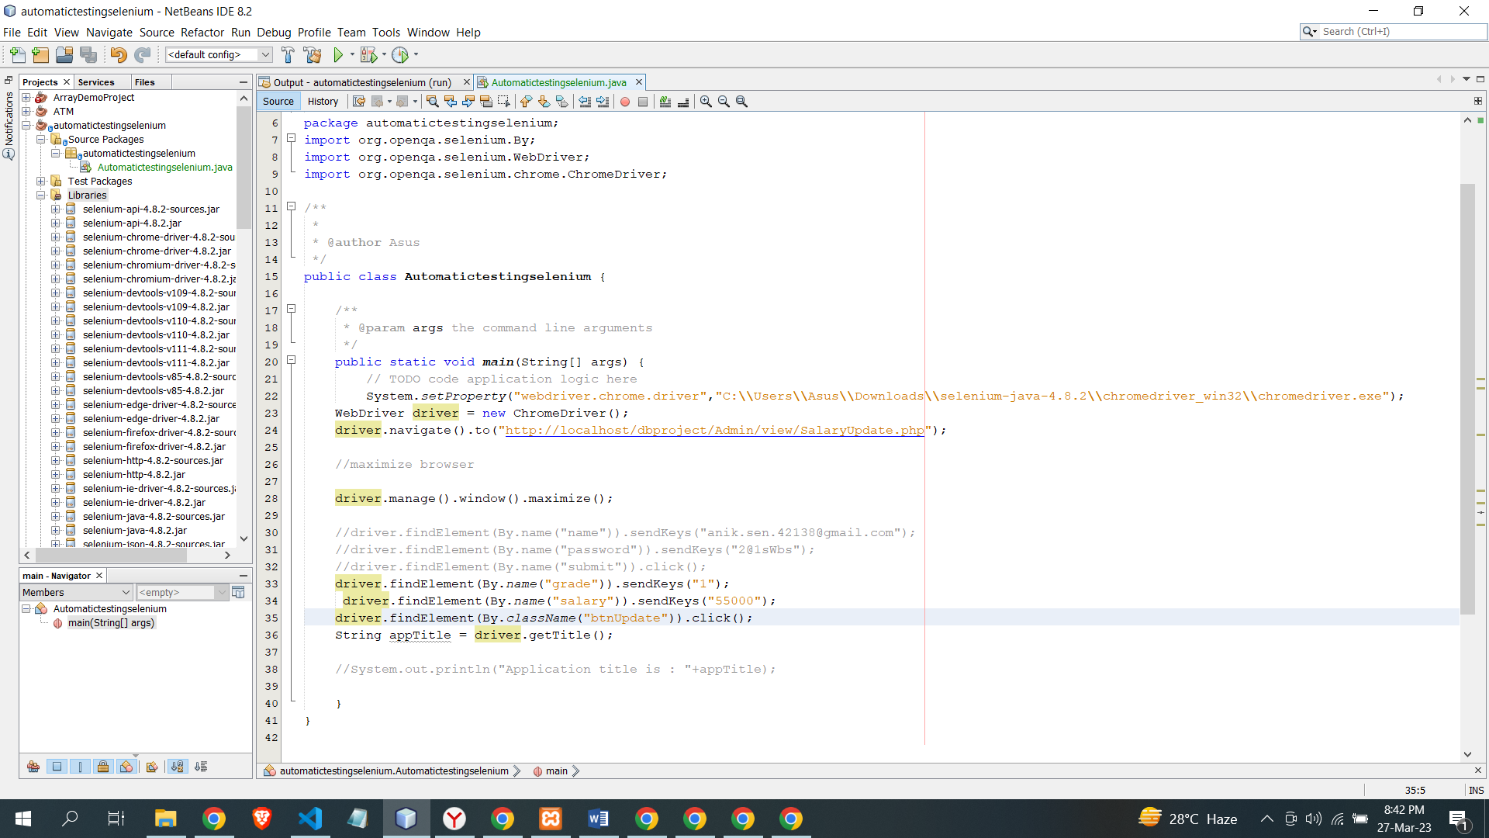

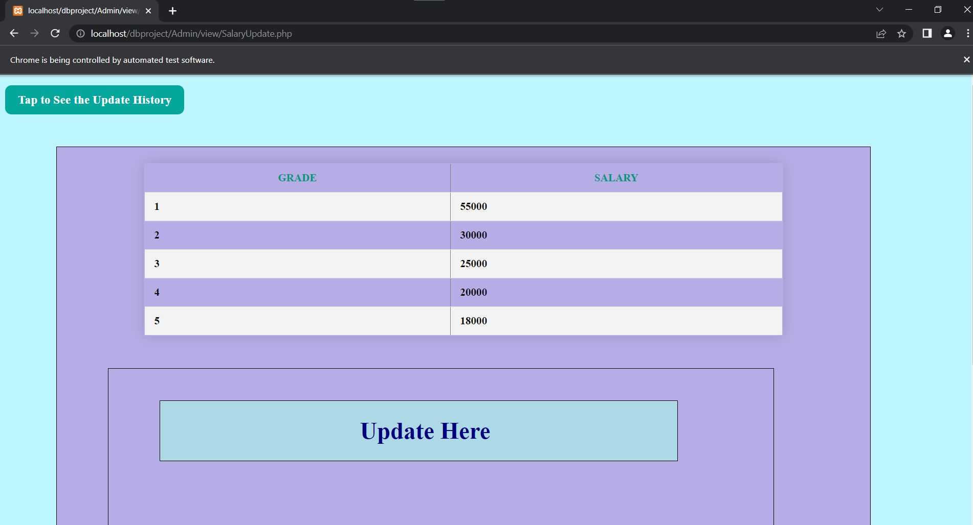

|  |  |  |  |  |
| --- | --- | --- | --- | --- |
| Project Name: Tour guide BD | | | Test Designed by: | |
| Test Case ID: #9 | | | Test Designed date: 24th March, 2023 | |
| Test Priority: High | | | Test Executed by: Fahim Alam | |
| Module Name: Insert grade with salary | | | Test Execution date: 27th March, 2023 | |
| Test Title: Insert the employee salary | | |  | |
| Description: Test the insert segment of employee salary | | |  | |
| Preconditions: N/A  Dependencies: N/A | | | | |
| Test Steps | **Test Data** | **Expected Results** | **Actual Results** | **Status** |
| 1. Go for insert 2. Enter employee grade 3. Enter salary 4. Click submit | Grade : 6  Salary : 23000 | Admin should insert employee grade with salary | As expected | Pass |
| Post Condition: N/A | | | | |

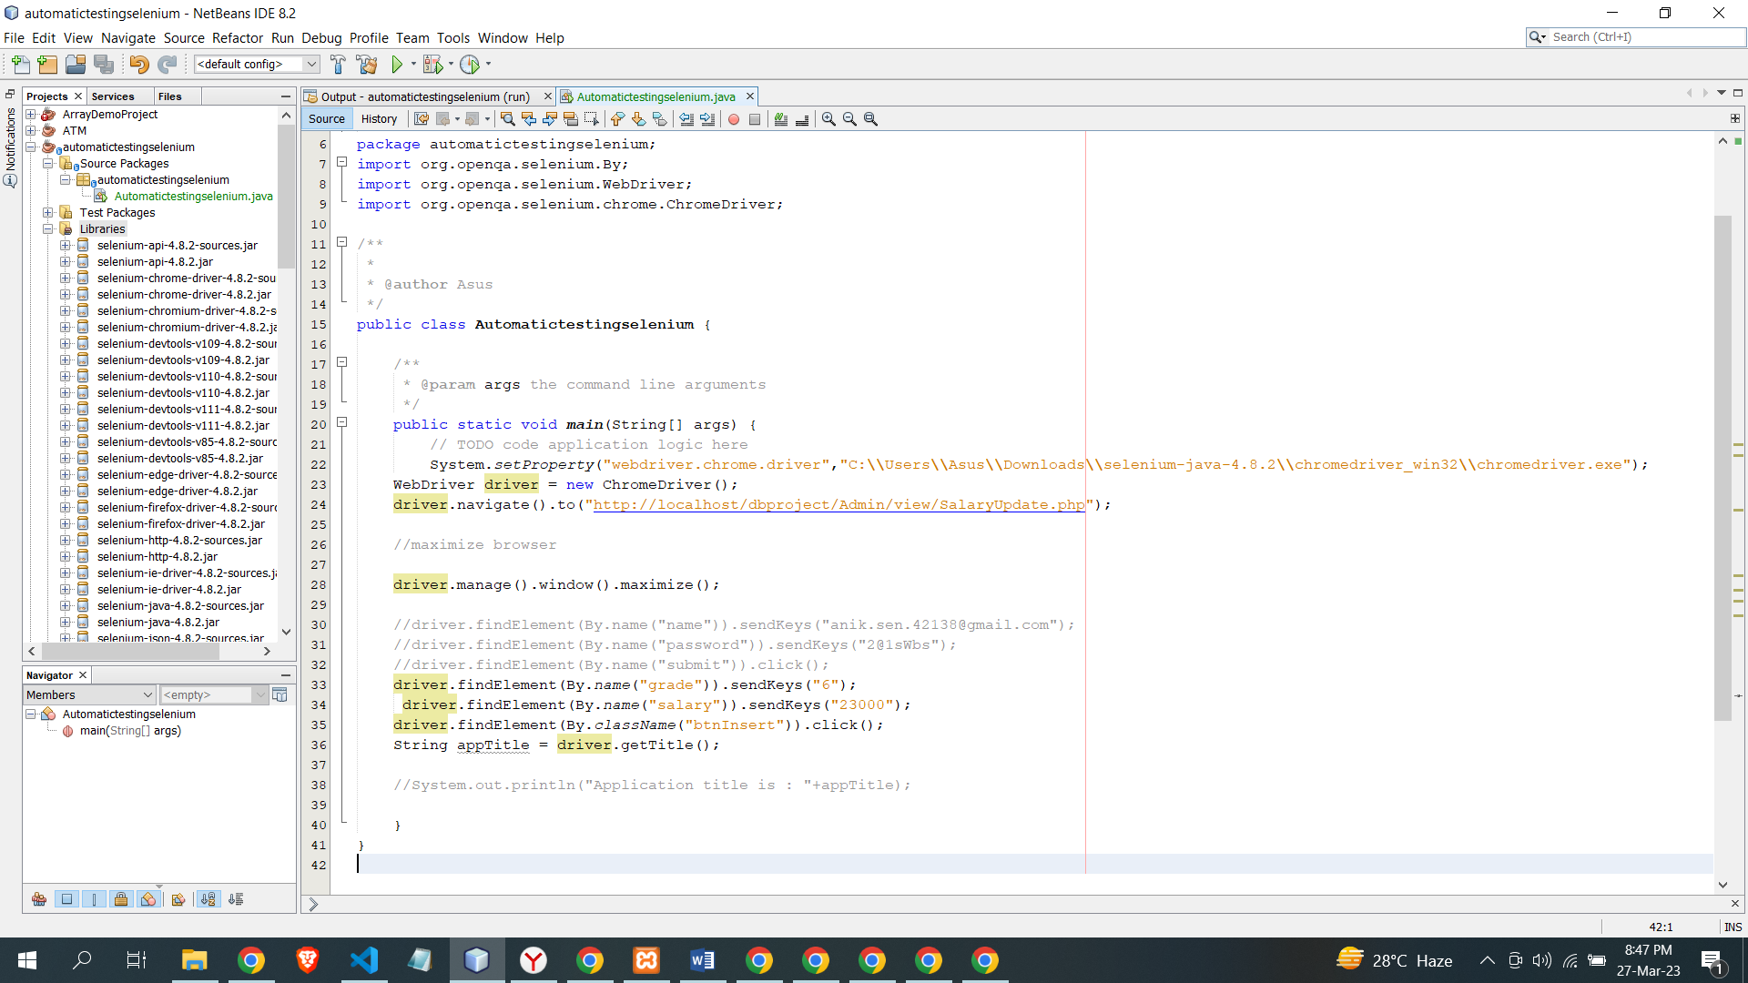

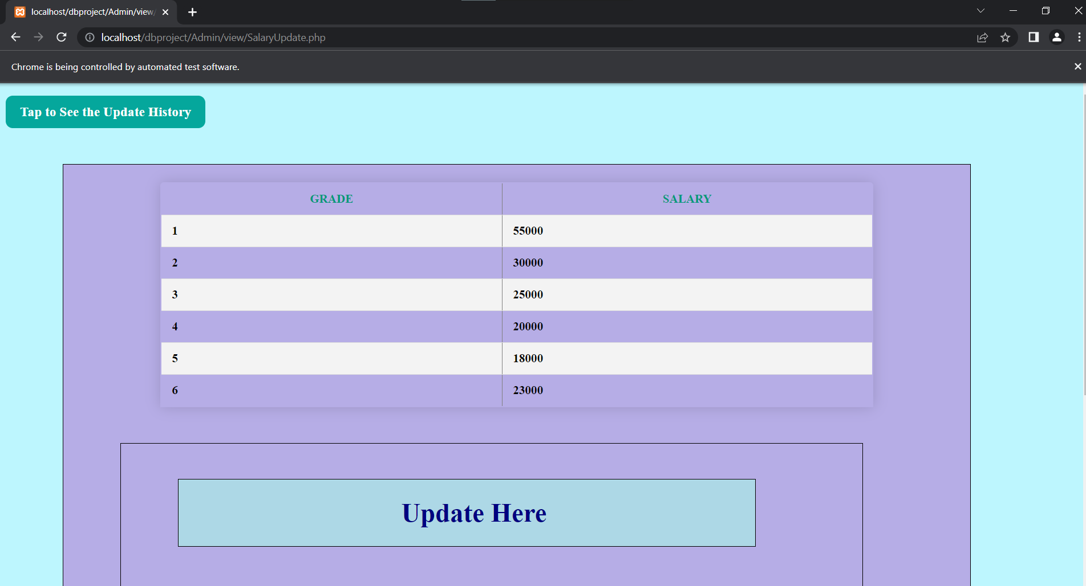

|  |  |  |  |  |
| --- | --- | --- | --- | --- |
| Project Name: Tour guide BD | | | Test Designed by: | |
| Test Case ID: #10 | | | Test Designed date: 24th March, 2023 | |
| Test Priority: High | | | Test Executed by: Fahim Alam | |
| Module Name: Delete grade with salary | | | Test Execution date: 27th March, 2023 | |
| Test Title: Delete the employee salary | | |  | |
| Description: Test the Delete segment of employee salary | | |  | |
| Preconditions: N/A  Dependencies: N/A | | | | |
| Test Steps | **Test Data** | **Expected Results** | **Actual Results** | **Status** |
| 1. Go for delete 2. Enter employee grade 3. Click submit | Grade : 6  Salary : 0 | Admin should Delete employee grade with salary | As expected | Pass |
| Post Condition: N/A | | | | |

